



Data Structures Dive
LAB MANUAL

Disclaimer: The content is curated from online/offline resources and used for educational purpose only
Data Structures Dive – Student / Shopping List Manager

Objective
By the end of this lab, you will be able to:
- Use GitHub Copilot to work with lists and dictionaries (key data structures in Python).
- Create, modify, access, and loop over lists and dictionaries with AI assistance.
- Understand why data structures are useful for storing and organizing collections of data (e.g., multiple items instead of separate variables).
- Build a simple manager program (e.g., student records or shopping list) that adds, removes, searches, and displays data.
- Prompt Copilot with detailed comments to generate list/dict operations, loops, and functions.
- Combine previous concepts (loops from Lab 1, functions from Lab 2) with data structures.
- Test the program interactively and debug minor issues using Copilot.

Equipment Required
- Computer/Laptop with Windows, macOS, or Linux.
- Visual Studio Code (VS Code) installed and configured.
- Python 3.10 or higher installed and added to PATH.
- GitHub Copilot extension installed and activated in VS Code (signed in with GitHub account).
- Internet connection (required for real-time Copilot suggestions).

Prerequisites
- Completed Module 3, Lab 1 (loops), and Lab 2 (functions) of Module 4.
- Comfortable with: variables, input(), print(), if-else, for/while loops, defining/calling functions, and using Copilot (accepting suggestions with Tab, refining prompts).
- Able to run .py files in VS Code terminal (green play button or right-click → Run Python File).
- Basic understanding that lists hold ordered items and dictionaries hold key-value pairs.

Procedure
Follow these steps in order.
- Preparation
  - Open VS Code.
  - Go to your Module 4 labs folder (e.g., "Module4_Labs").
  - Create a new file: lab3_data_manager.pys
  - Save it (Ctrl+S) and confirm Python interpreter is selected (bottom status bar).
  - Add header comments:
# Lab 3: Data Structures Dive – Student / Shopping List Manager
# Objective: Use lists and dictionaries with Copilot
# Date: [Your Date]
- Part A: Working with Lists – Simple Shopping List
  - Type this comment and press Enter:
# Create an empty list for shopping items
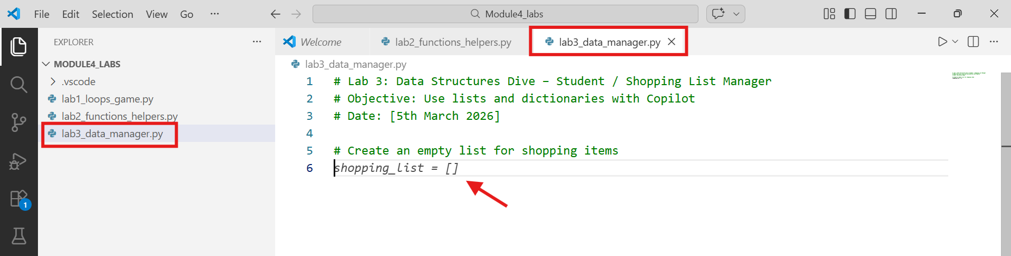
- Copilot may auto-suggest or help with: shopping_list = []
  - Add items with comment:
# Add 5 items to the shopping list using append (e.g., "milk", "bread", "eggs", "rice", "oil")
    - Accept Copilot suggestions like:
shopping_list.append("milk")
shopping_list.append("bread")
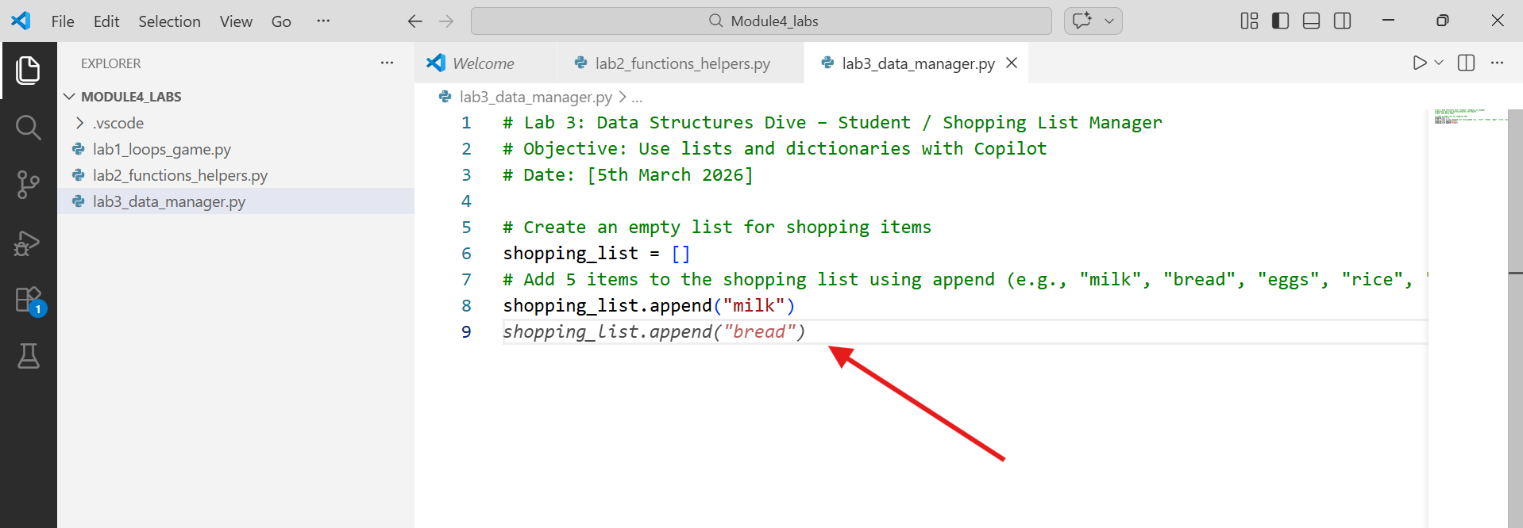
  - Display the list:
# Print the entire shopping list with a loop
    - Let Copilot generate:
print("Shopping List:")
for item in shopping_list:
print("- " + item)
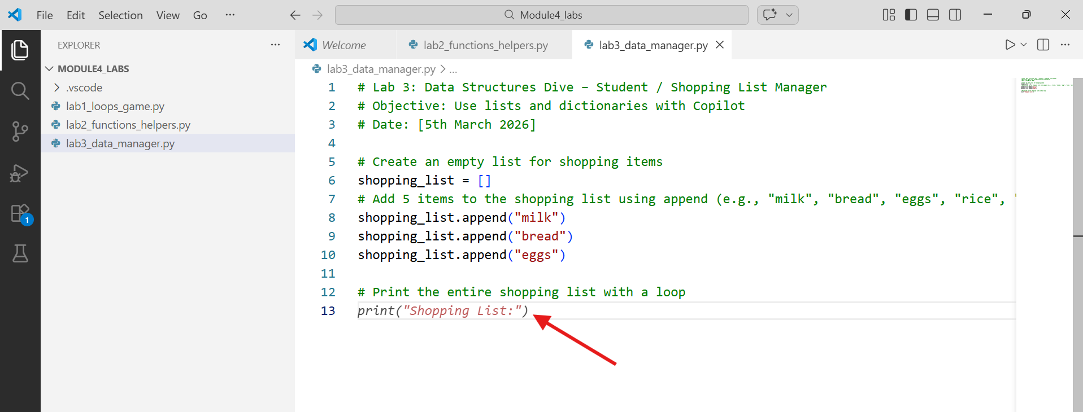
  - Run and check output. Experiment: Add shopping_list.remove("eggs") → rerun.
- Part B: Dictionaries – Student Records
  - New section:
# Create a dictionary for one student: name, roll_no, marks (in 3 subjects)
# Example: student = {"name": "Amit", "roll_no": 101, "marks": {"Math": 85, "Science": 92, "English": 78}}
  - Copilot should suggest a nested dict structure. Accept and create 2–3 more students (hardcode or use input).
  - Better: Use a list of dictionaries for multiple students:
# Create a list called students that holds 3 dictionaries (each a student with name, age, marks dict)
    - Prompt Copilot if needed: # students = [] then append 3 student dicts
  - Access data:
# Print name and total marks for each student using a for loop
    - Copilot may generate:
for student in students:
total = sum(student["marks"].values())
print(f"{student['name']} - Total Marks: {total}")
  - Add a function from Lab 2 style:
# Function to calculate average marks for a student dict
    - Accept def get_average(student): return sum(student["marks"].values()) / len(student["marks"])
    - Call it in the loop.
- Part C: Interactive Shopping List Manager
  - Combine everything: Build a menu-driven program. Start with:
# Interactive Shopping List Manager
# Use while loop for menu: 1. Add item, 2. Remove item, 3. View list, 4. Exit
  - Copilot can help generate the full structure:
shopping_list = []

while True:
print("\n1. Add item\n2. Remove item\n3. View list\n4. Exit")
choice = input("Enter choice: ")
if choice == "1":
item = input("Item to add: ")
shopping_list.append(item)
elif choice == "2":
item = input("Item to remove: ")
if item in shopping_list:
shopping_list.remove(item)
else:
print("Not found!")
elif choice == "3":
print("Shopping List:", shopping_list)
elif choice == "4":
break
else:
print("Invalid choice!")
  - Enhance: Add quantity using dict instead of simple list (e.g., {"item": "milk", "qty": 2}). Prompt: # Change to list of dicts: each item has name and quantity
  - Test: Add 4 items, remove one, view, exit.
- Part D: Reflection & Testing
  - Run full program. Fix errors with Copilot (highlight → # explain/fix this error).
  - Worksheet notes:
    - Difference between list and dict you noticed?
    - Best Copilot prompt for data structures?
    - How many lines Copilot wrote vs. you typed?
    - One real-world use for this kind of manager.
Conclusion
In this lab, you explored lists (ordered collections) and dictionaries (key-value pairs) with heavy GitHub Copilot support. These structures let you handle multiple related pieces of data efficiently - essential for real apps like inventories, student databases, or to-do lists. Copilot helped generate loops over structures, nested dicts, and interactive menus when you used clear, specific comments.

